**Rename file to 2022 – 2023 please**

Question 1

Question 2

C

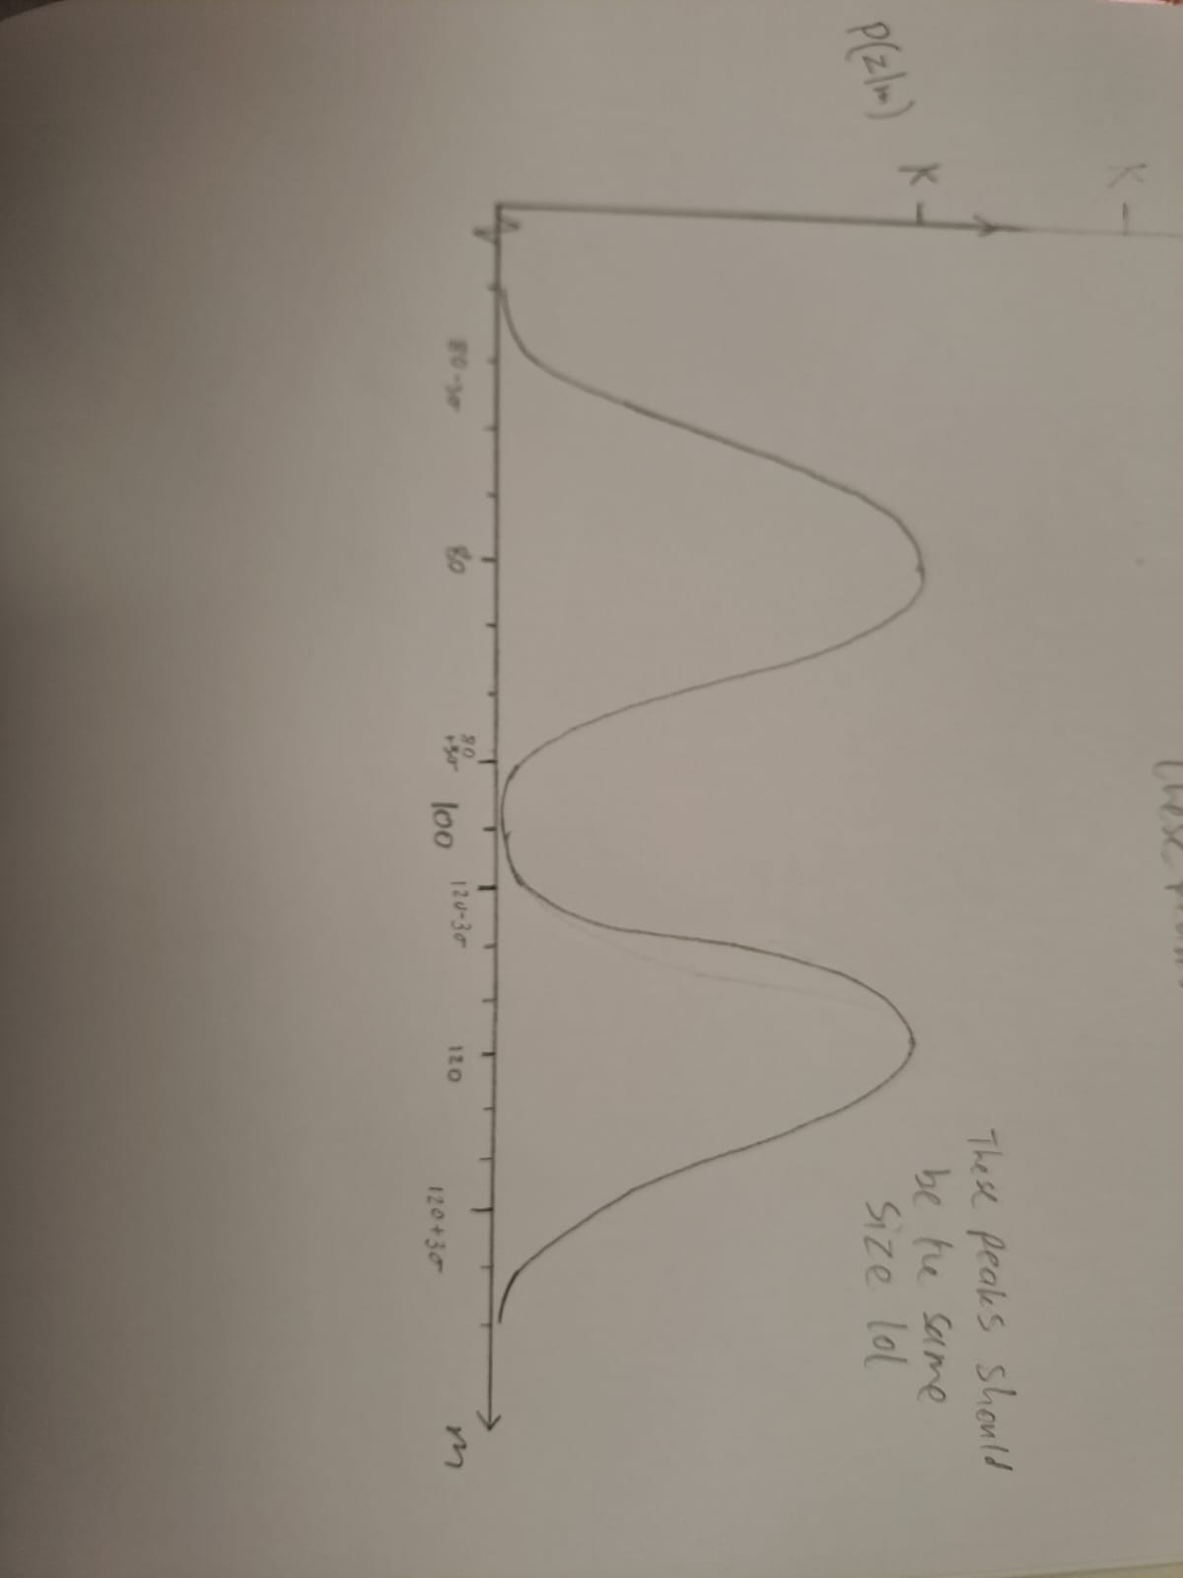Since sigma=5 and gaussian tails off by 3 sigma from the peak, the two gaussians are ~0 when they start overlapping in the middle, so it looks like the two peaks just next to each other. Pretty stupid sonar but ok